Q1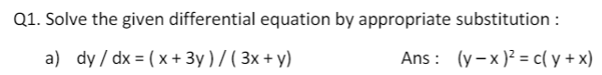

1/ Find the substitution, integrating both sides

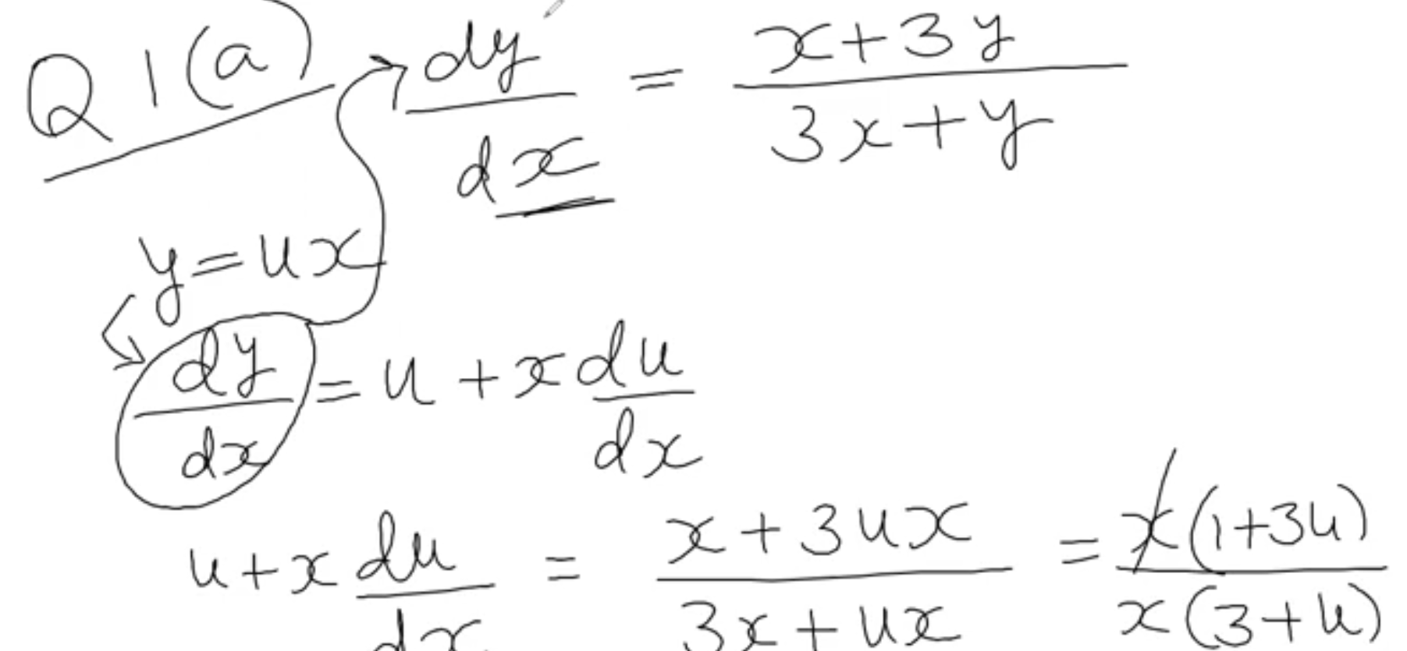

2/ Simplify and separate each variable

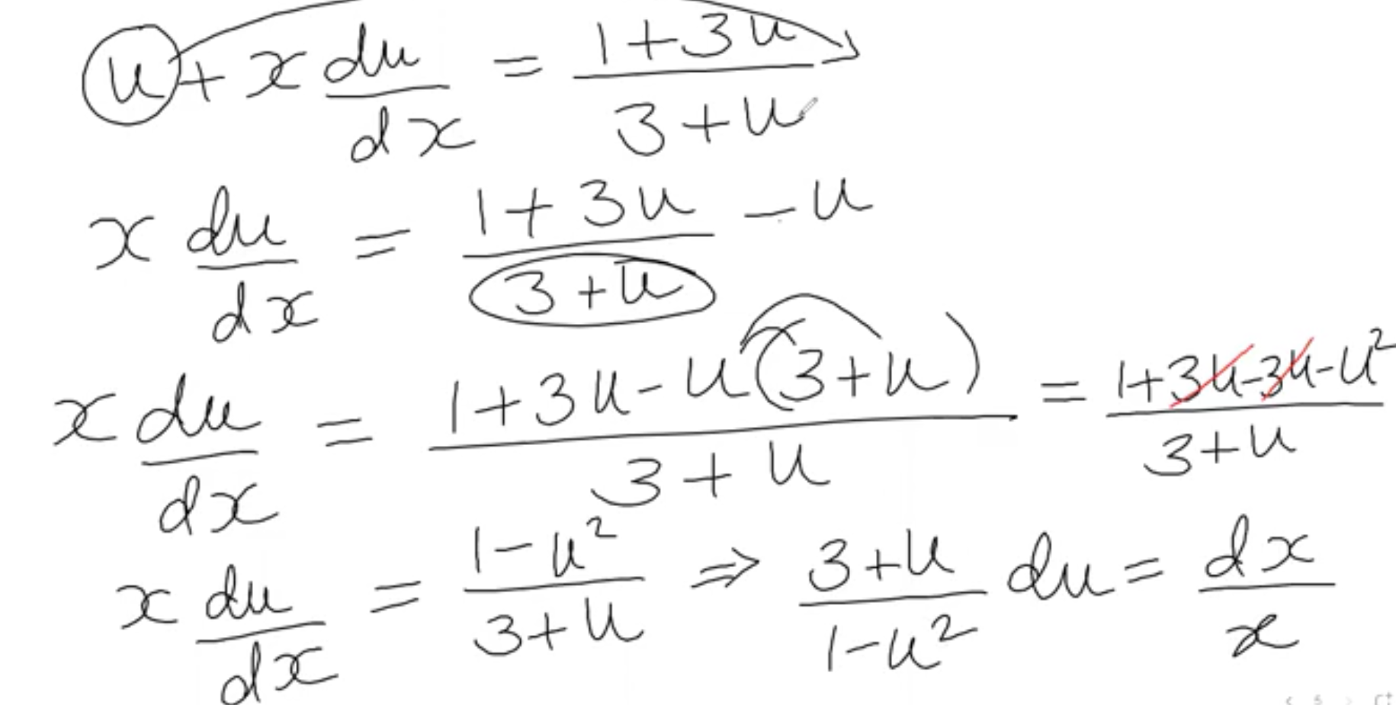

3/ Keep solving

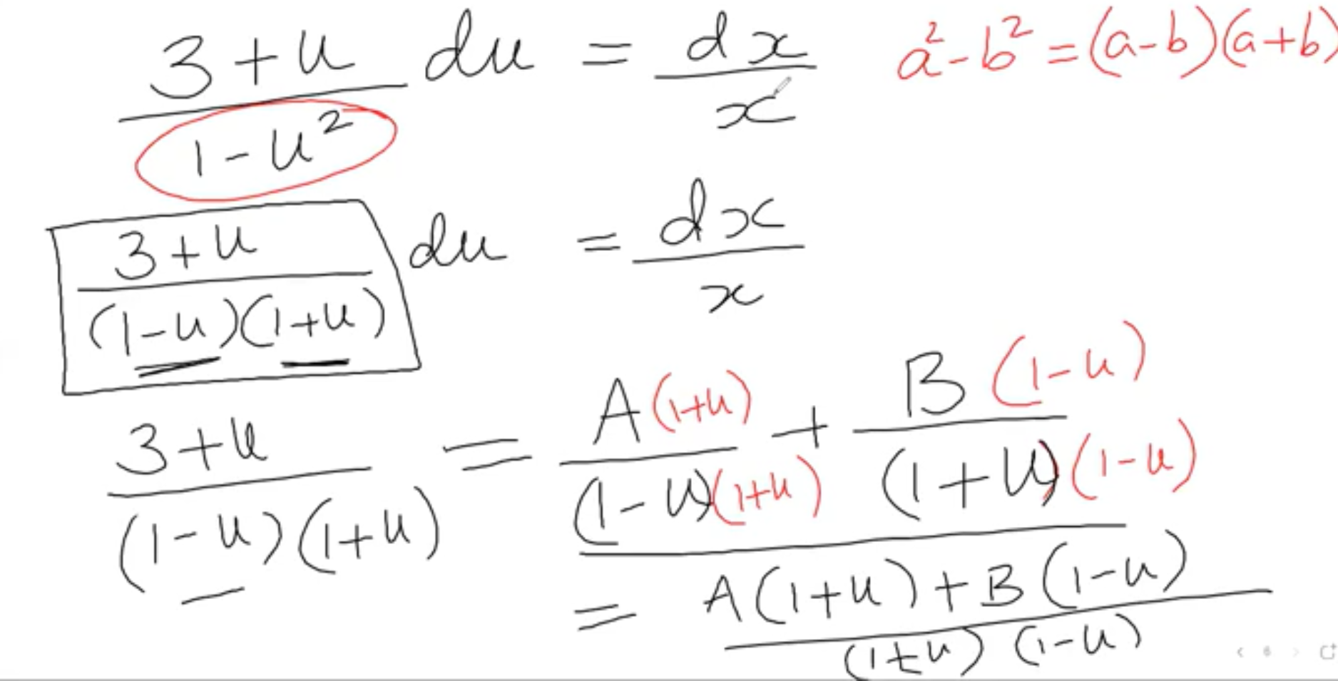

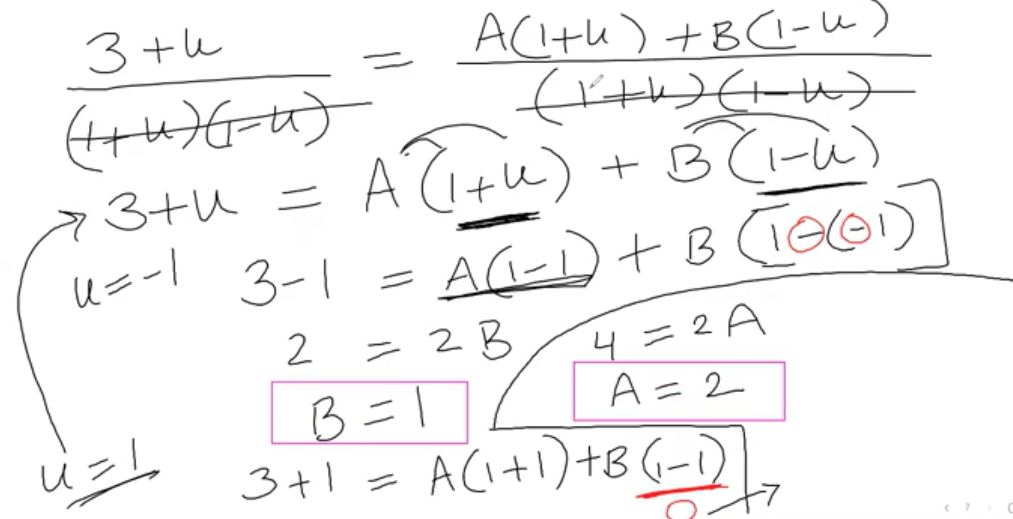

4/ Plug the value of A and B into the substitute equation. Then integrating both sides of the separable function

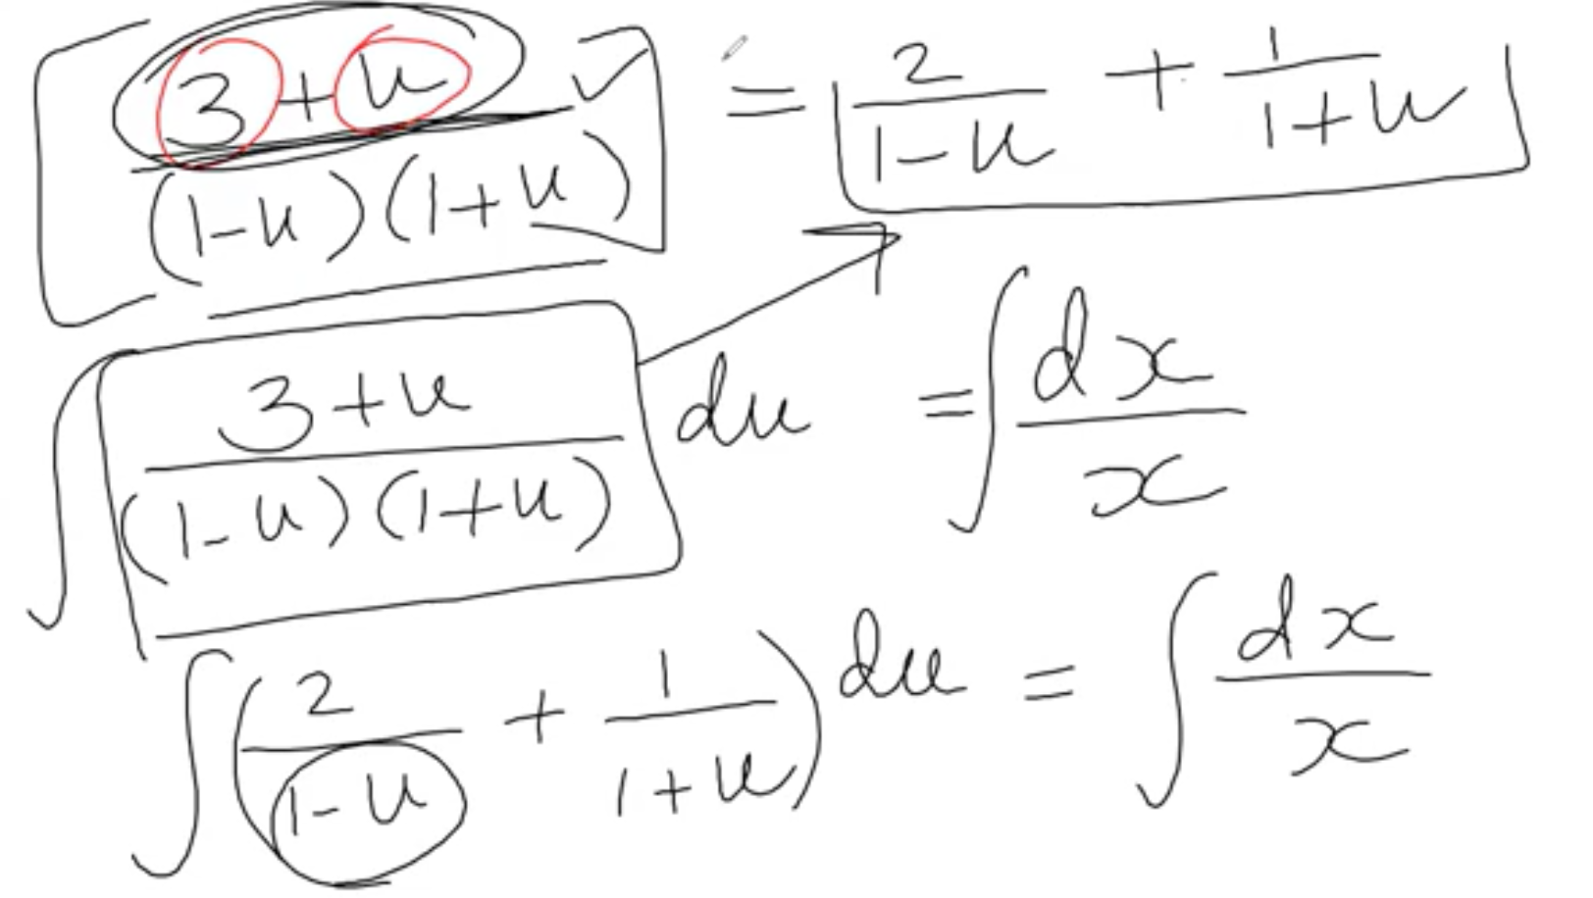

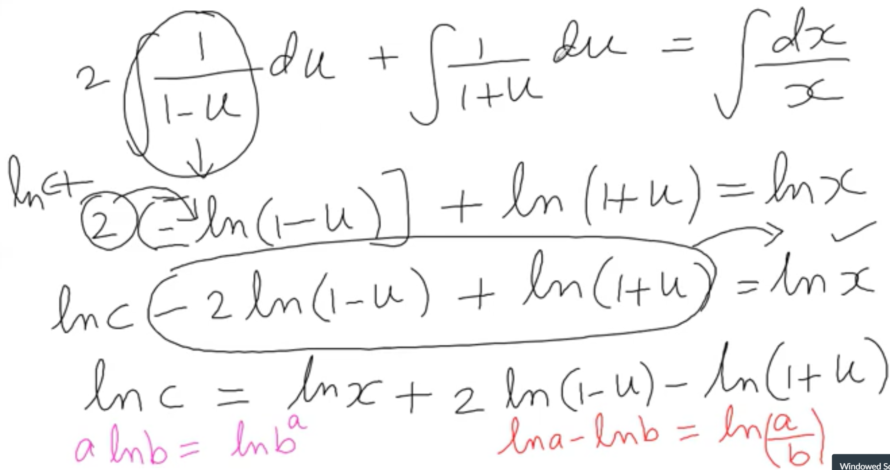

5/ Use the substitute function to find u and plug in the function on Step 4

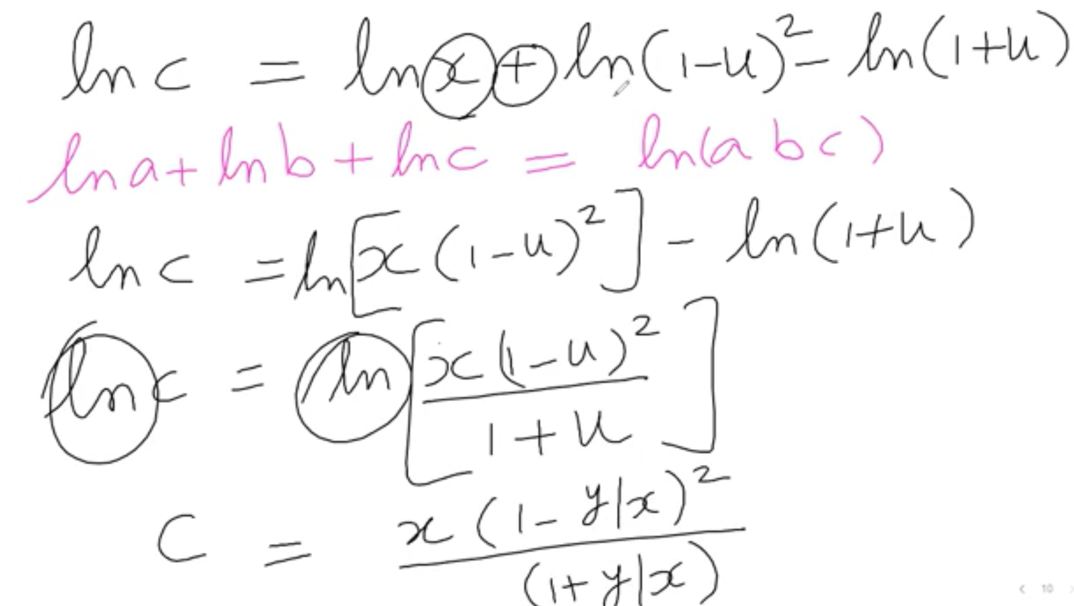

6/ Simply find the function to find c or function y

Can’t find the y because we can’t separate the x,y in this case

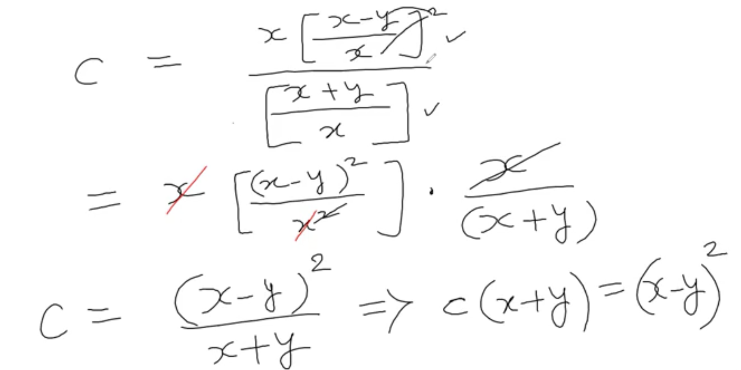



1/ find the substitute and integrating with respect to x

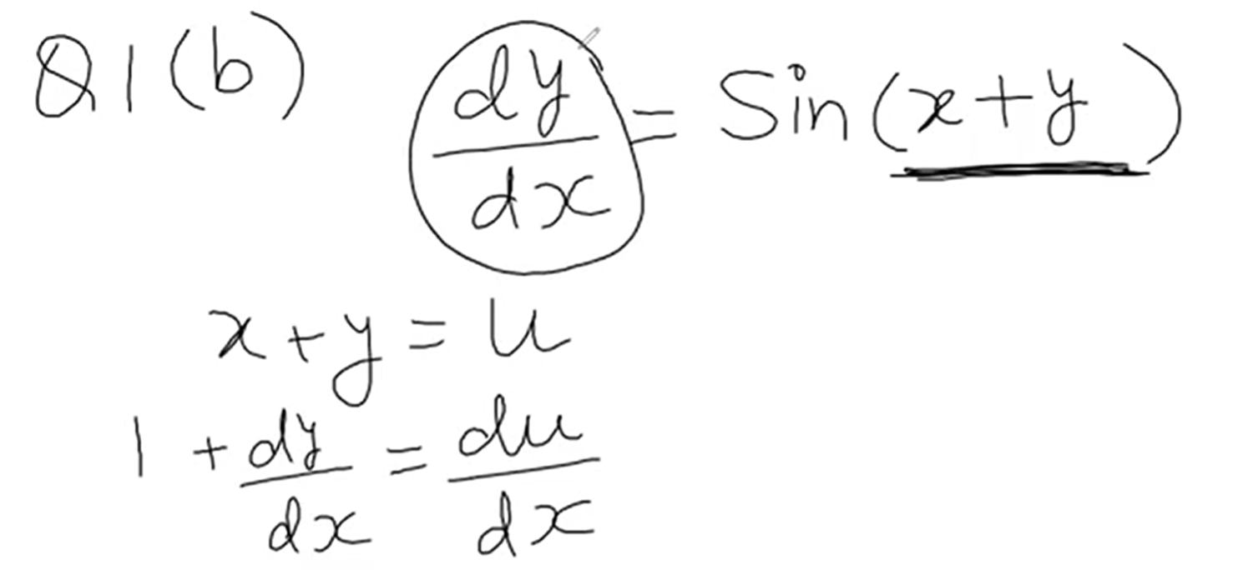

2/ Find the dy/dx

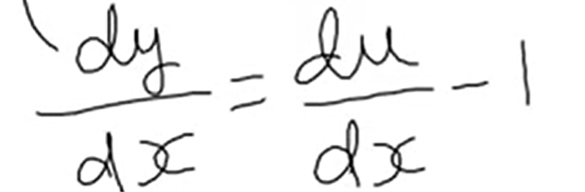

3/ Plug in the original equation and separable variables

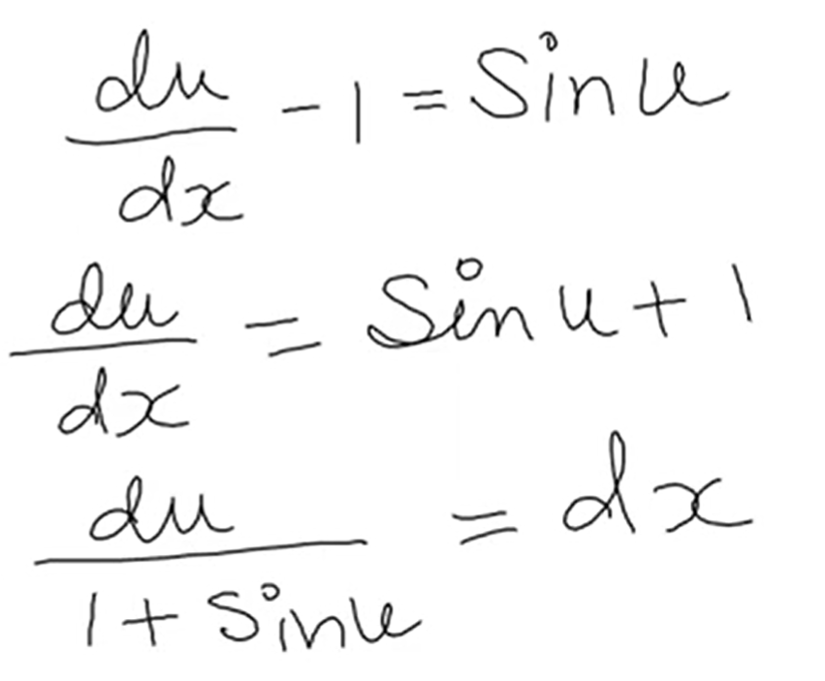

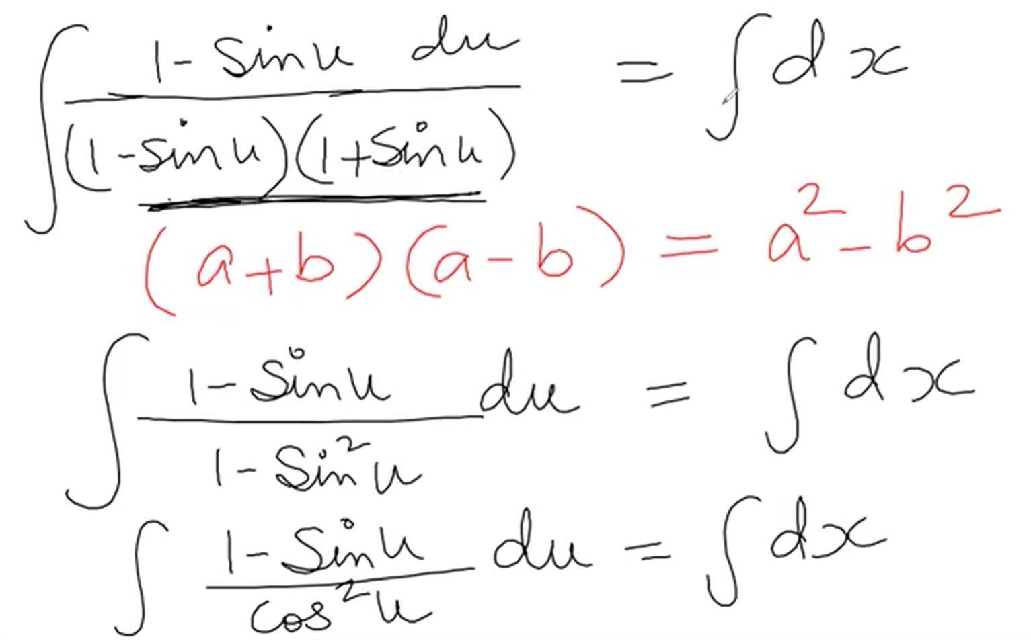

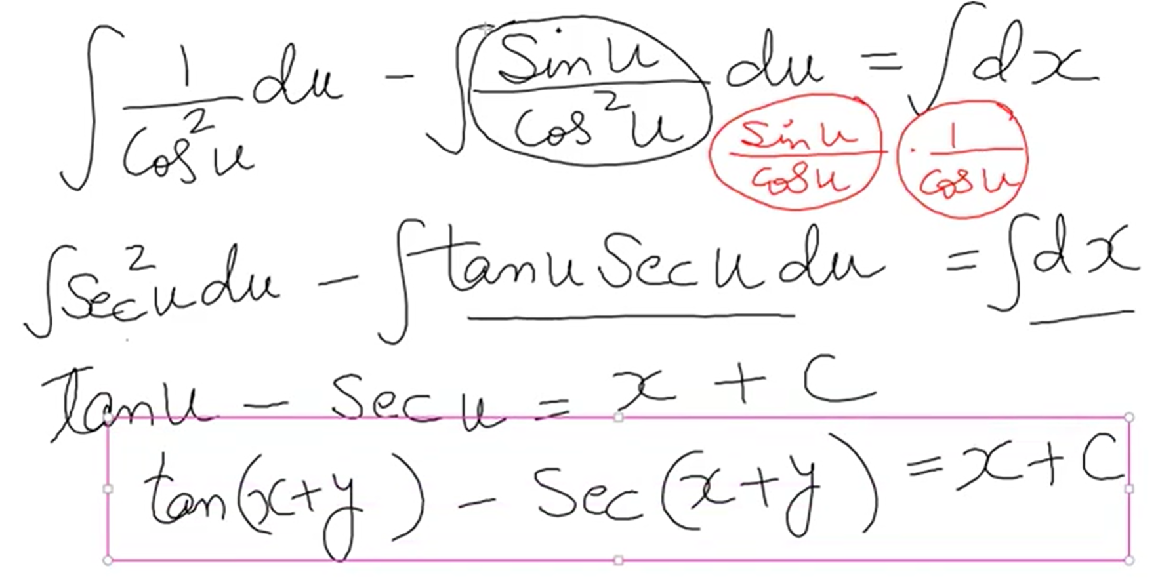



Q2.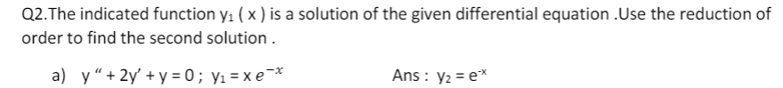

<https://www.symbolab.com/solver/second-order-differential-equation-calculator/y%20%2B%202y%E2%80%99%20%2B%20y%20%3D%200%2C%20%20y_%7B1%7D%3Dxe%5E%7B-x%7D>

<https://www.emathhelp.net/calculators/differential-equations/differential-equation-calculator/>

1/ Set a new y2 equation base on y1

Then find derivative of y2 with respect to variable of function (maybe x), y2’’

Plug them into the original equation

Simplify

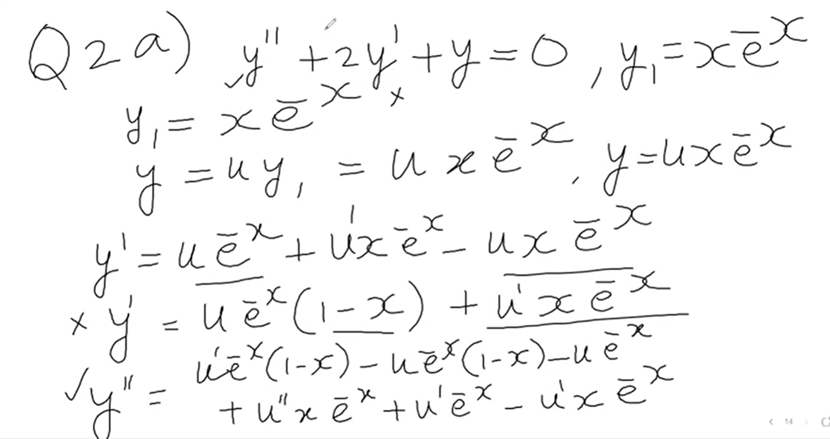

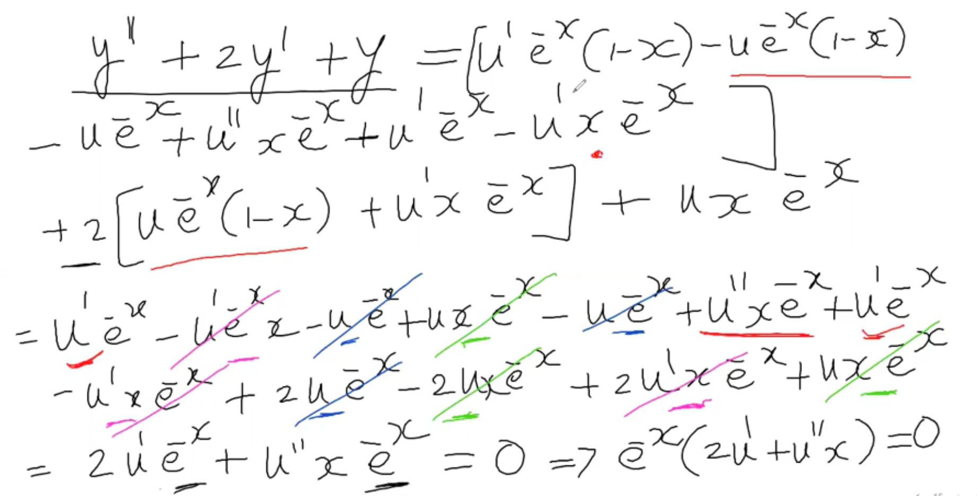

2/ Set w’ = u’’ and w = u’

Have the standard form Using 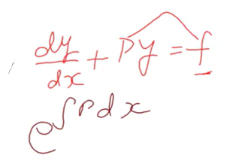 to find I.F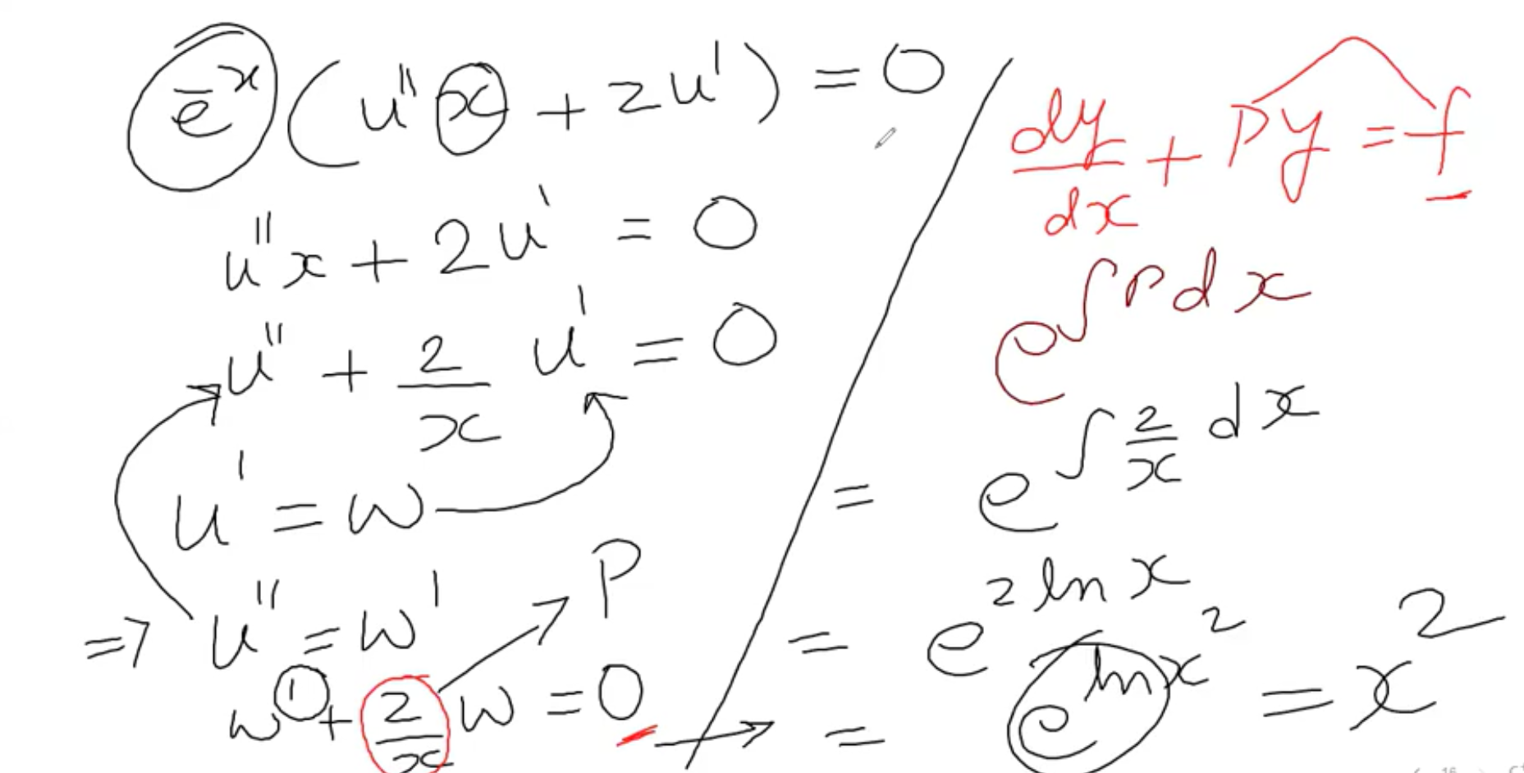

3/ Using 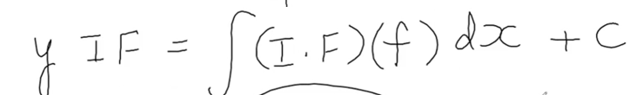

Find w = something = u’. Integral both sides to get u

Plug u into the y2 equation

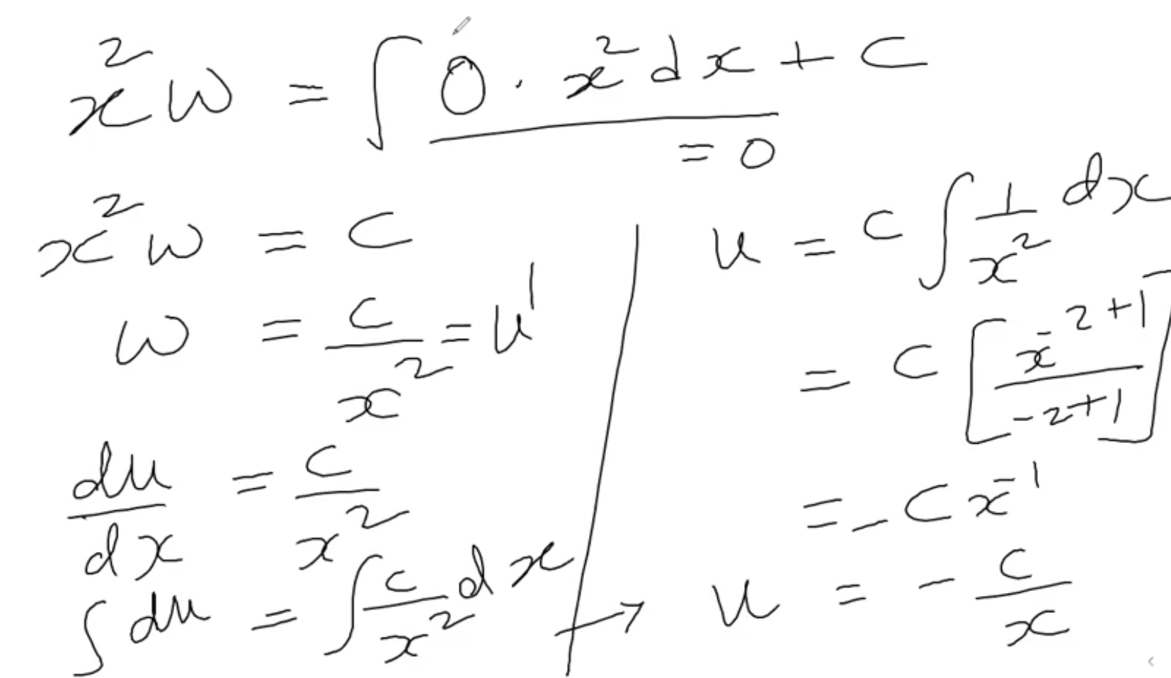

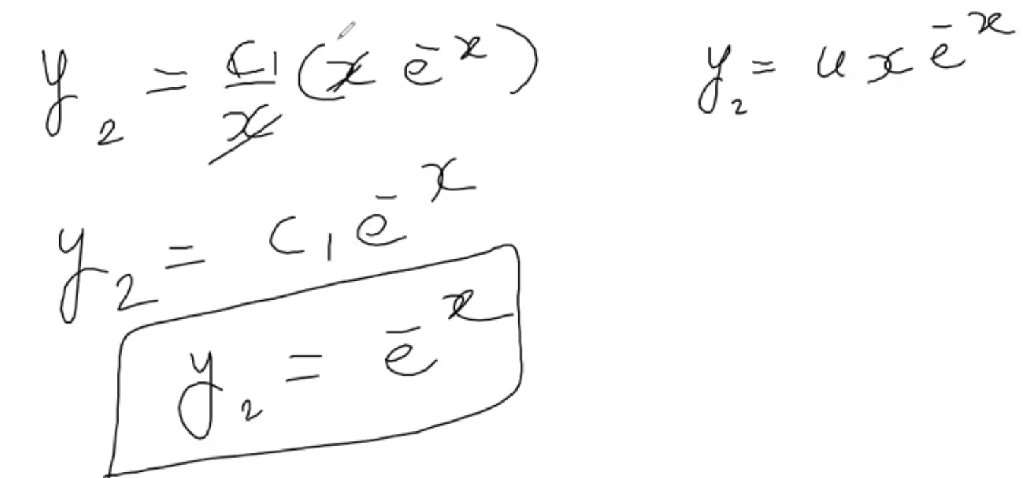



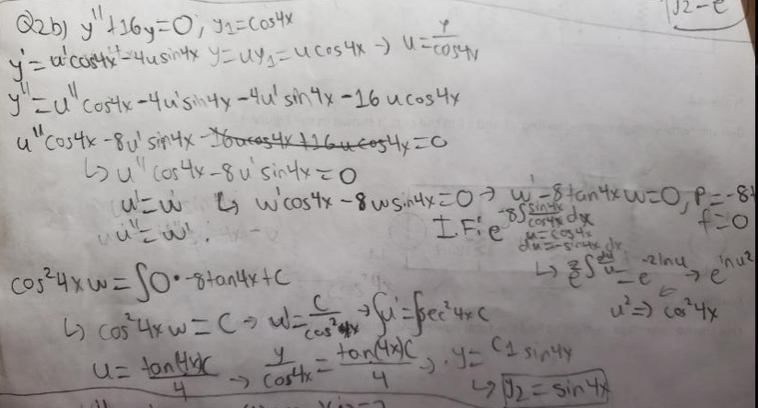

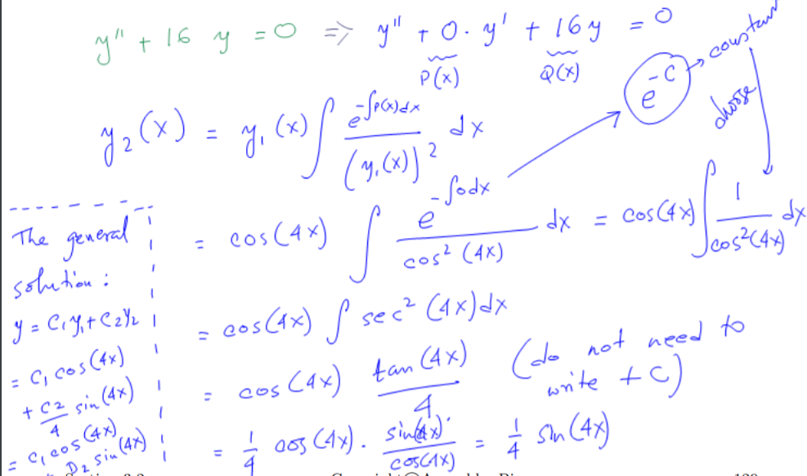

Q3.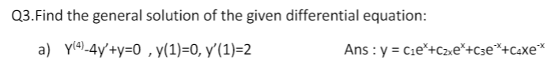

Cases for different types of roots



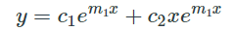



1/ Substitute d/dx = D, transfer the function to D function

Set the D function to m function -> Find roots

2/ After finding roots, check cases to choose the right formula

3/ Have the function -> Use information y = something and y’ = something to find c1, c2

1/ Substitute d/dx = D, transfer the function to D function

Set the D function to m function -> Find roots

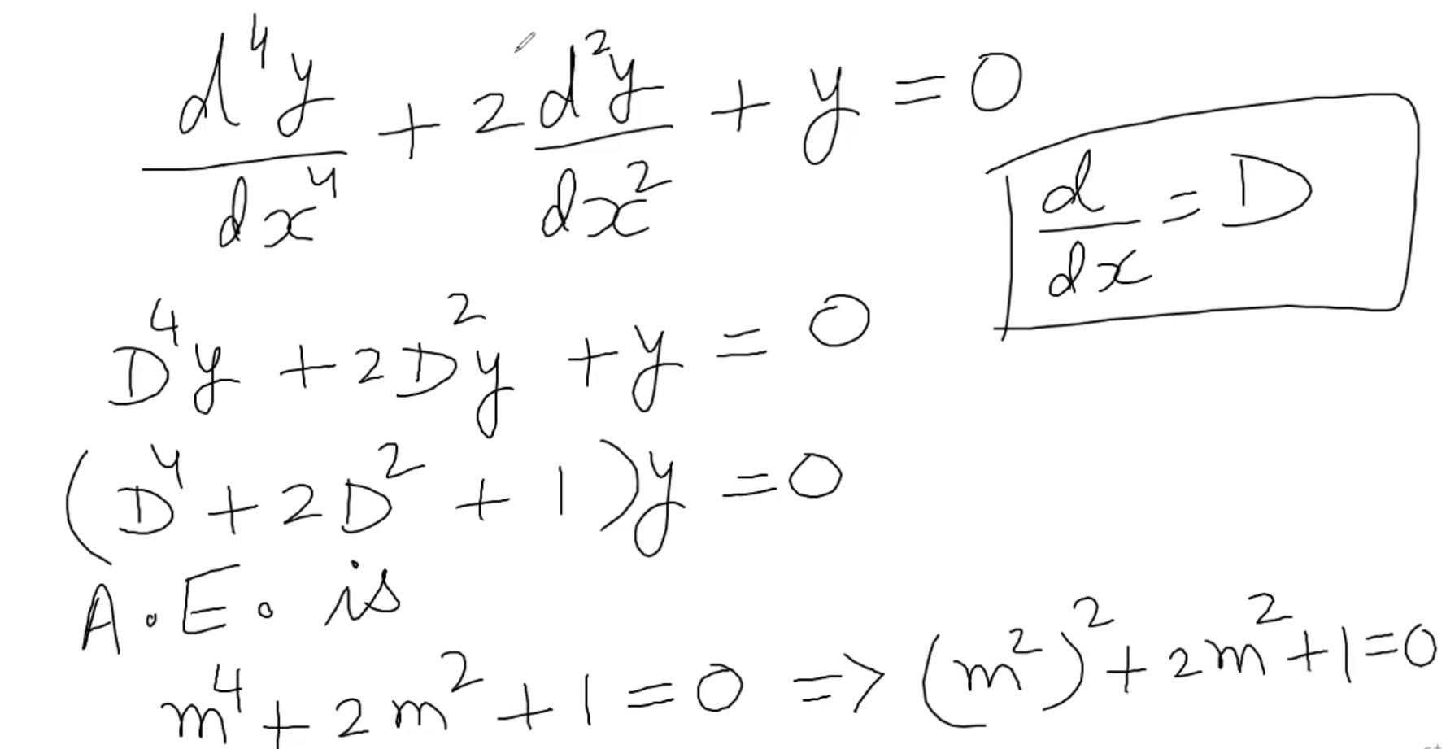

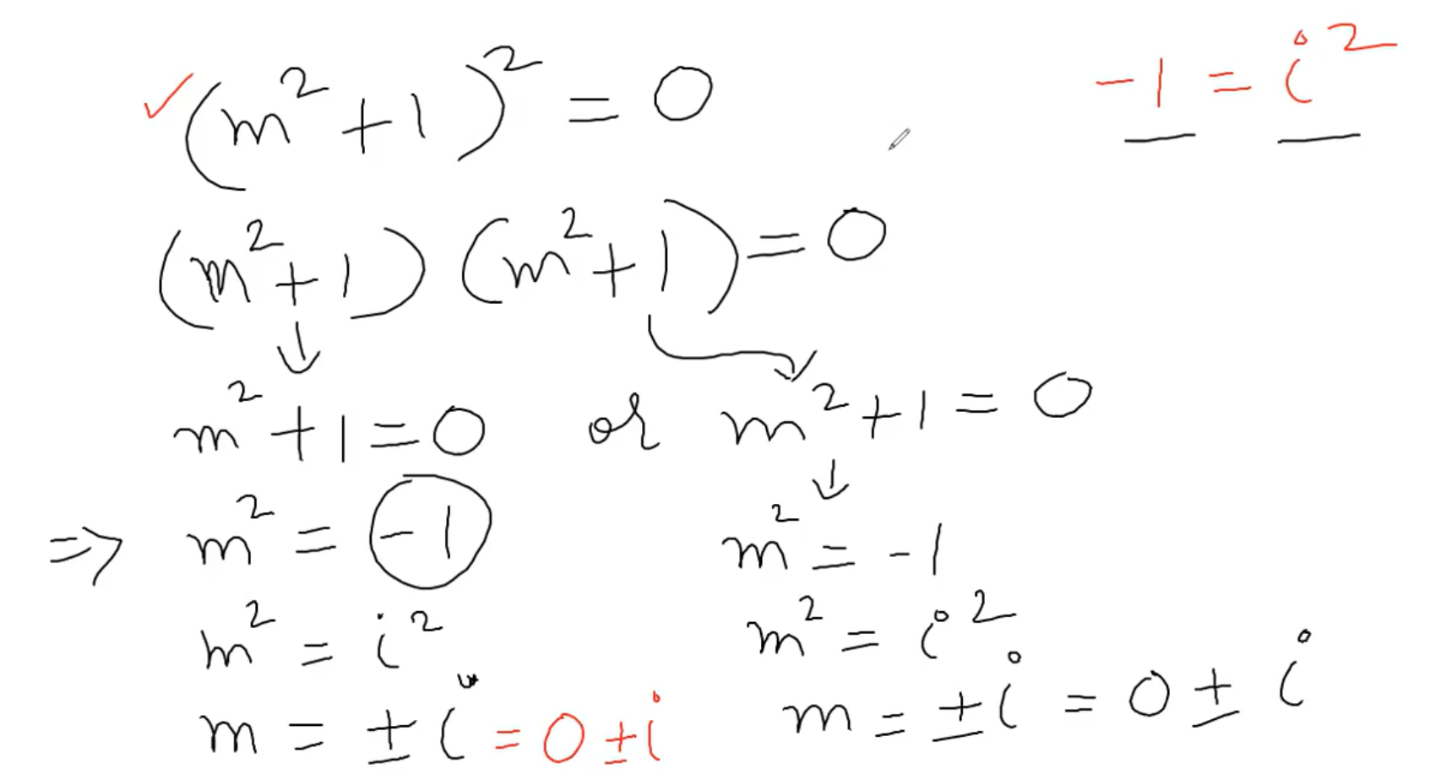

2/ After finding roots, check cases to choose the right formula

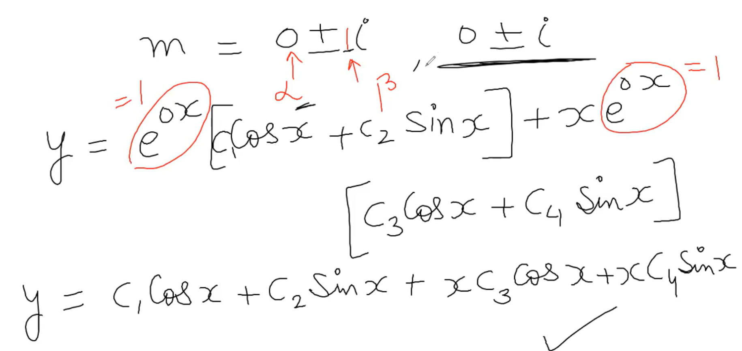

3/ Have the function -> Use information y = something and y’ = something to find c1, c2



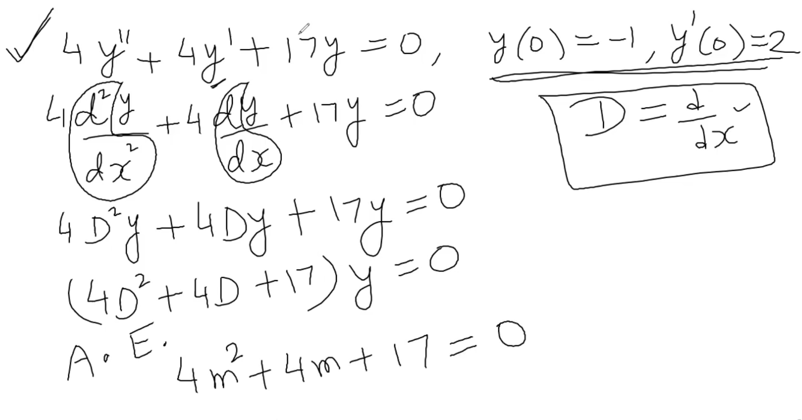2/ Using 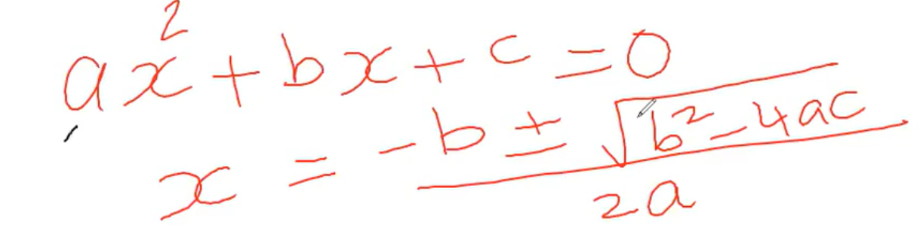to find the roots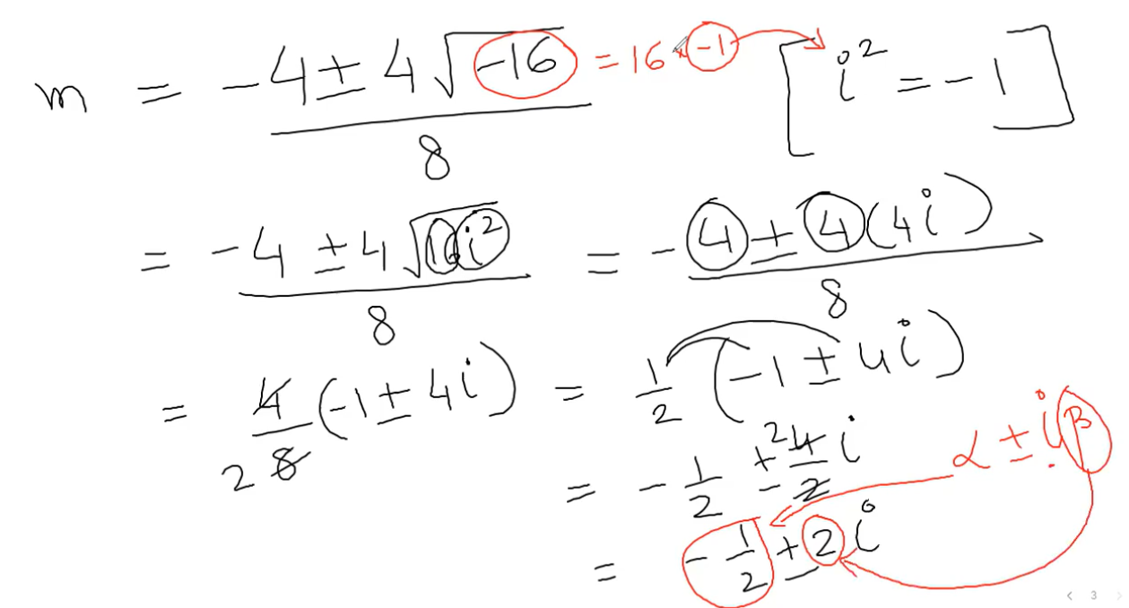

3/ Have the function -> Use the information y = something, y’ = something to find c1 and c2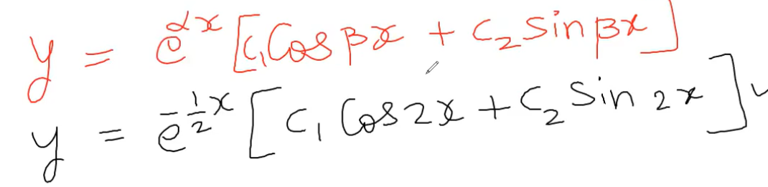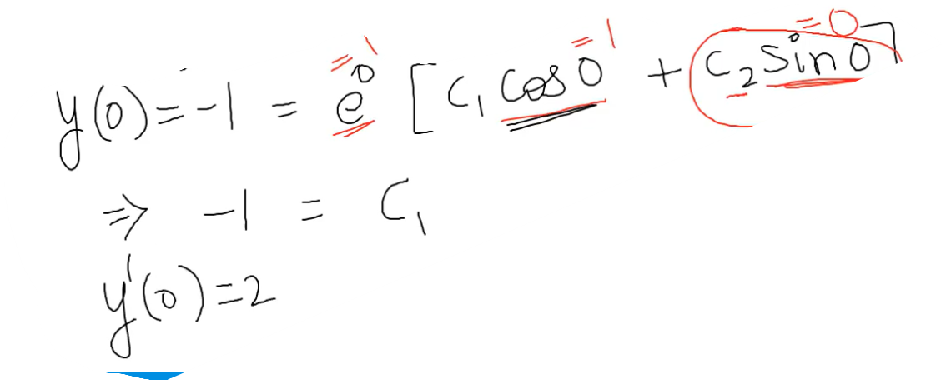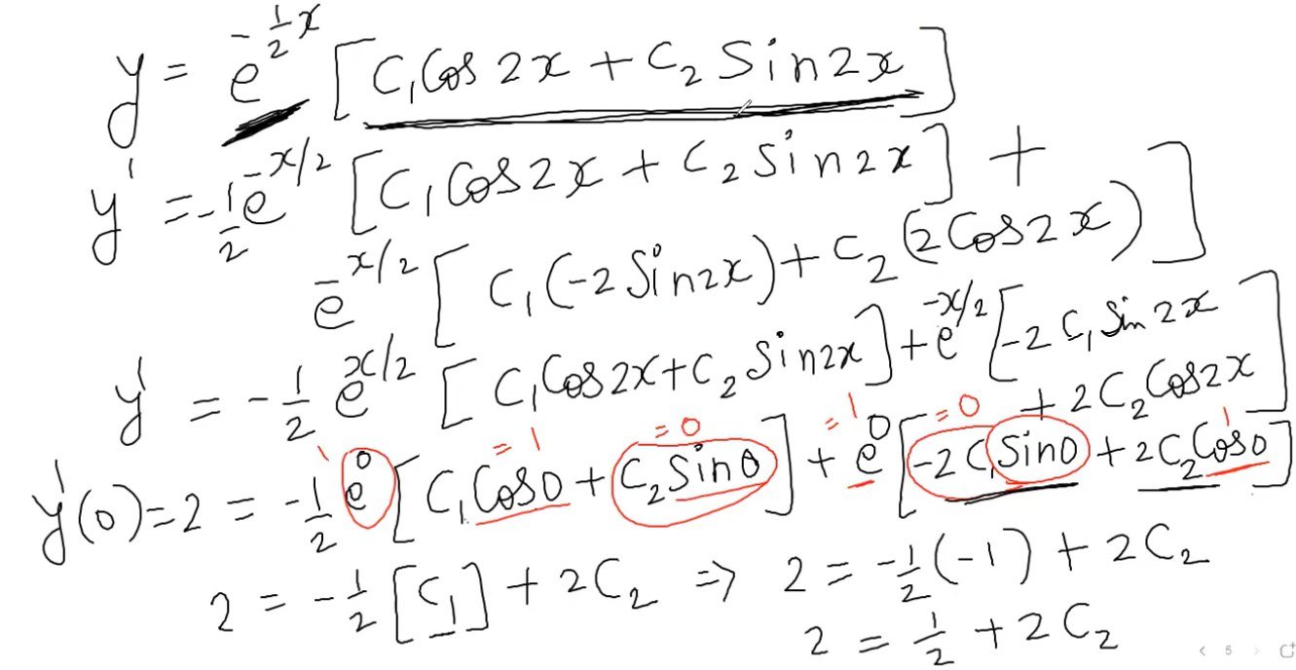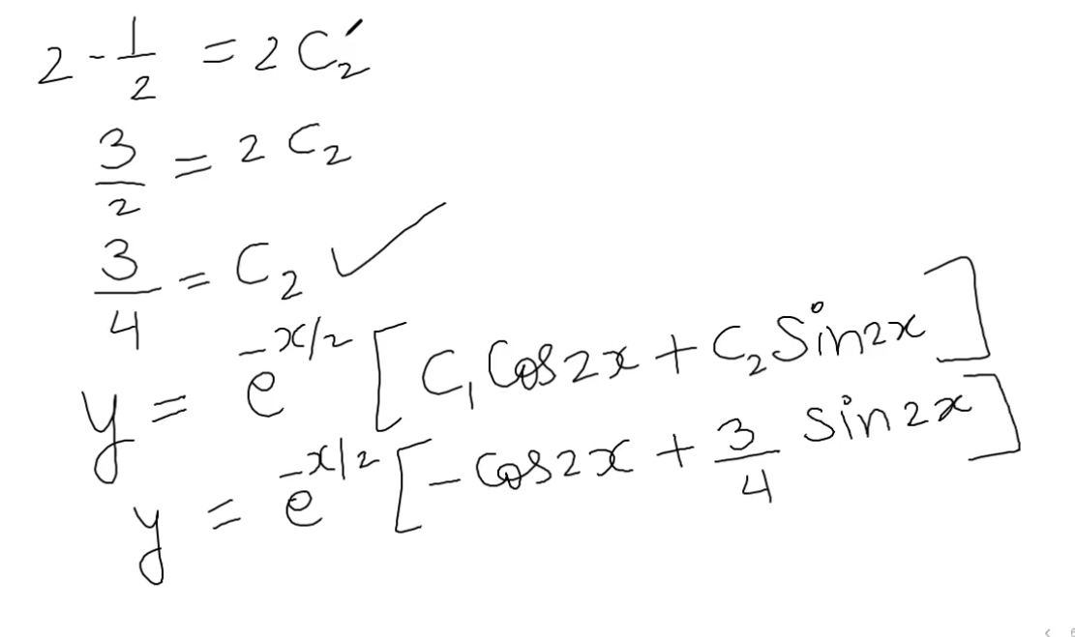

Q4.

1/ Solve yc: y’’ + y = 0 -> Having roots

2/ Check cases to use the right formula

3/ Find yp4/ Use this table to transform to yp1, yp2 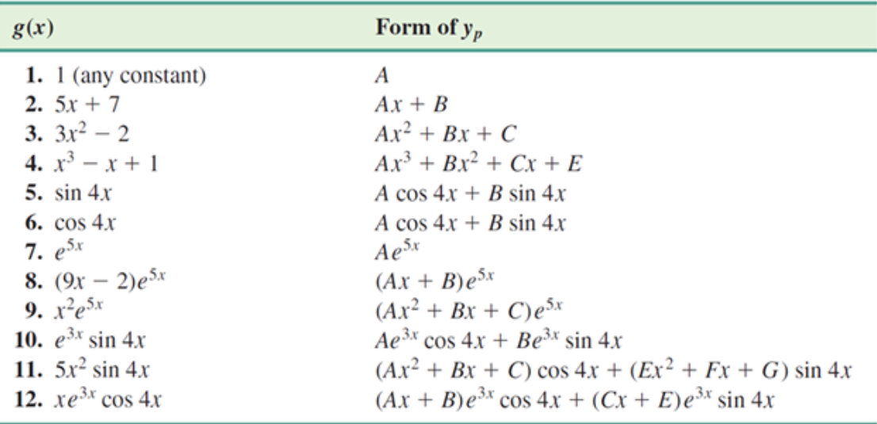

5/ Check if any term of y is duplicated or not. If yes follow this rule

6/ Plug yp1 and yp2 into yp

7/ Have yp -> Plug in y’’ + y = the given function (ptrinh đề bài)

7..1/ Find y’’p to solve the new function

8/ Simplify

9/ Having each term from both sides -> Find C, E, A, B

10/ Plug C, E, A, B into the yp function

11/ Have the new yp -> plug yp, yc into y function

12/ Use the given information to find c1, c2

13/ Plug c1, c2 into the function in step 11

1/ Solve yc: y’’ + y = 0 -> Having roots

2/ Check cases to use the right formula

3/ Find yp

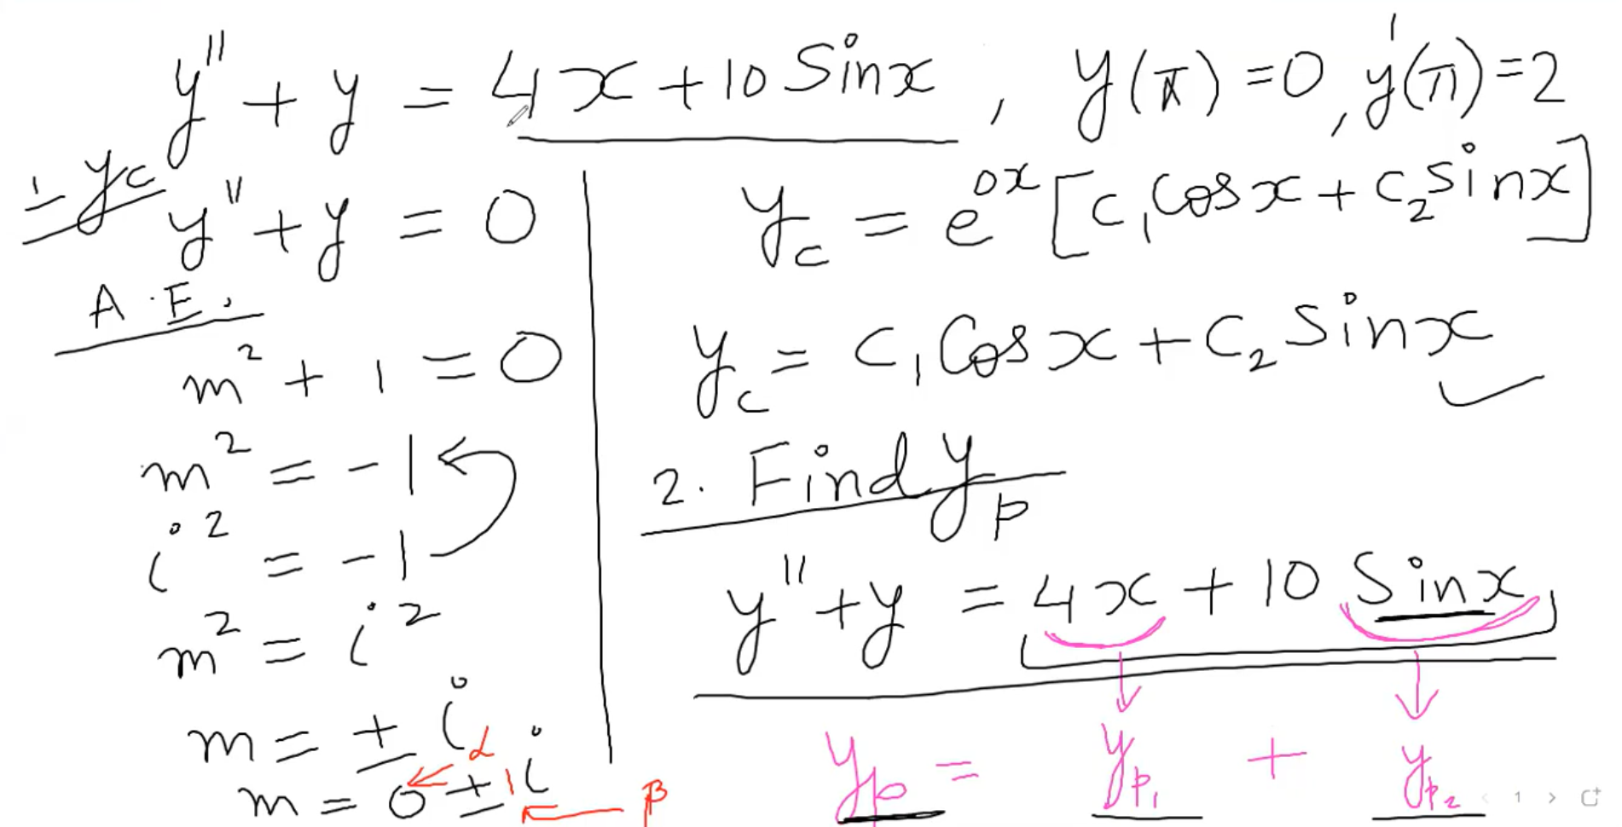

4/ Use this table to transform to yp1, yp2 

5/ Check if any term of y is duplicated or not. If yes follow this rule 

6/ Plug yp1 and yp2 into yp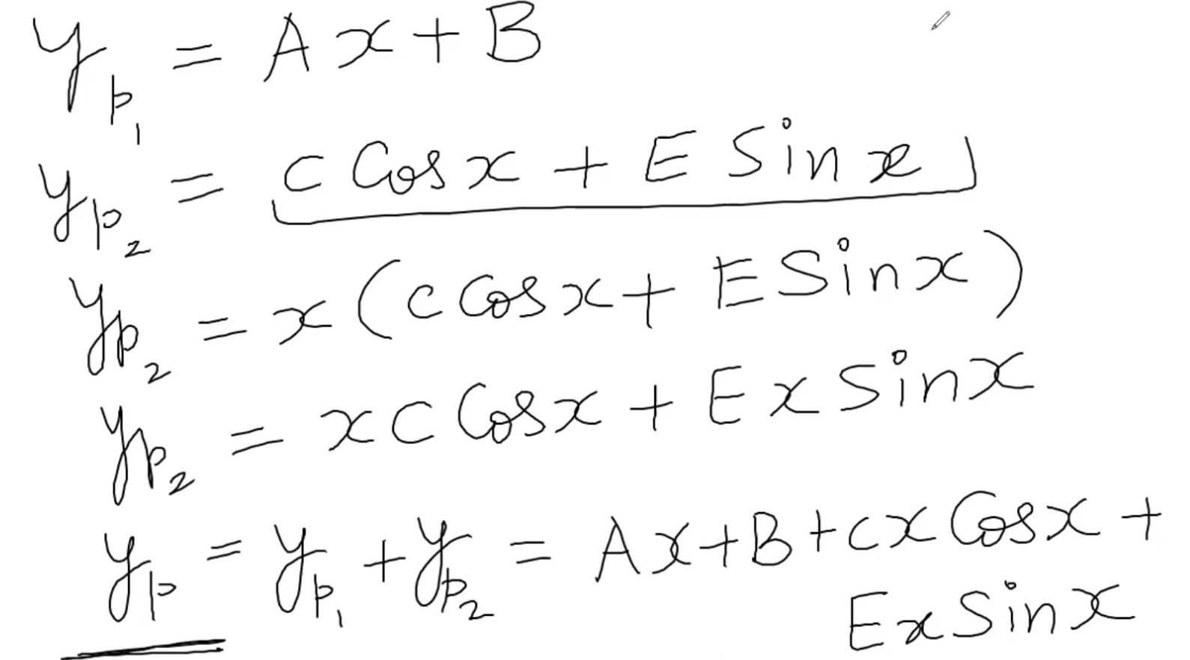

7/ Have yp -> Plug in y’’ + y = the given function (ptrinh đề bài)

Find y’’p to solve the new function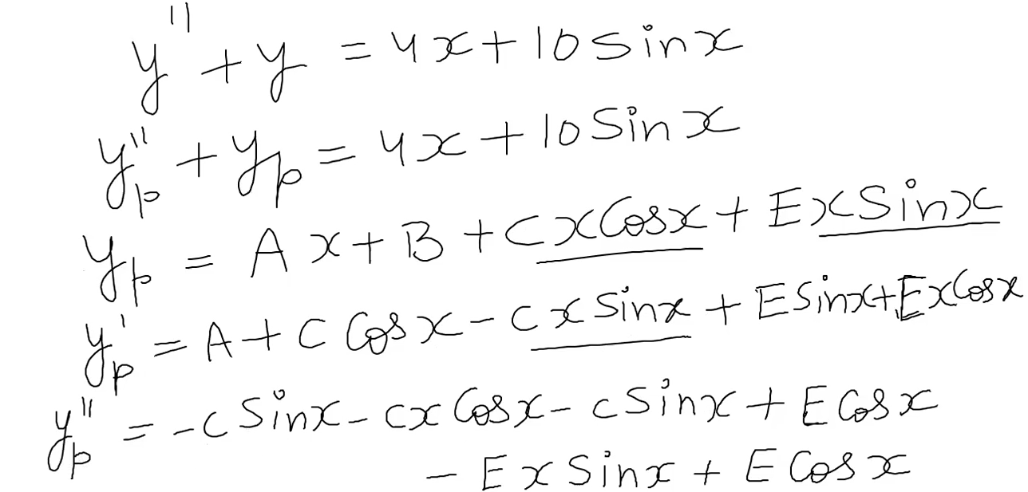

8/ Simplify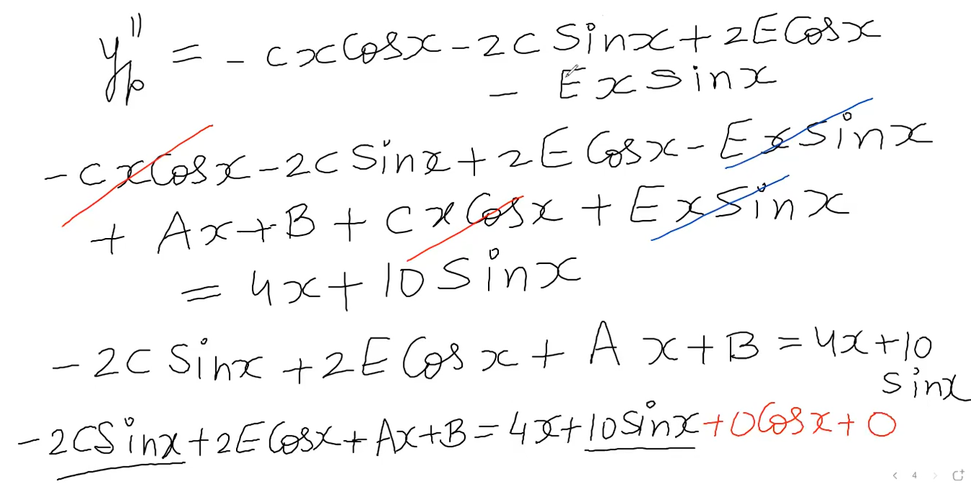

9/ Having each term from both sides -> Find C, E, A, B

10/ Plug C, E, A, B into the yp function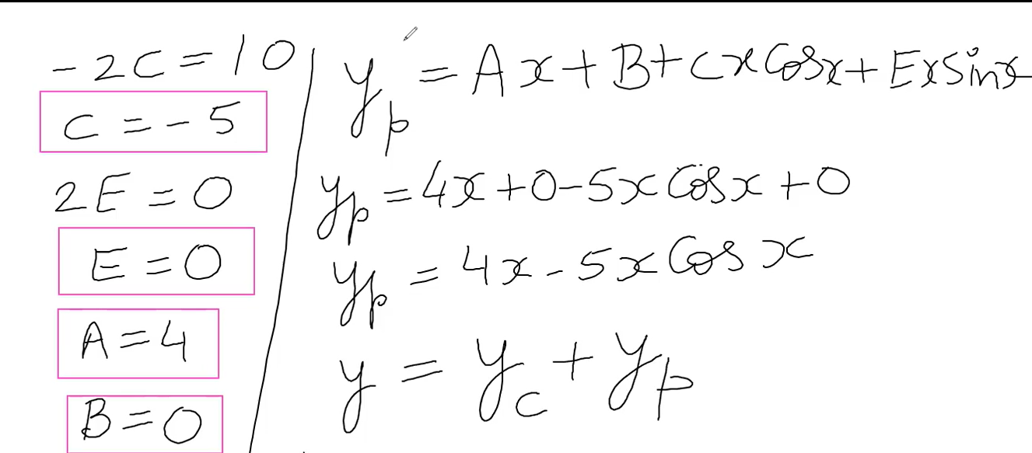

11/ Have the new yp -> plug yp, yc into y function

12/ Use the given information to find c1, c2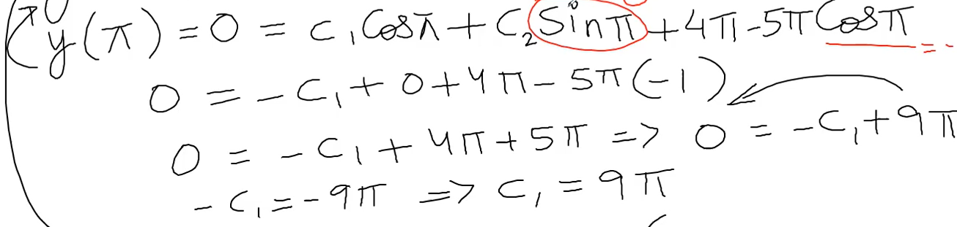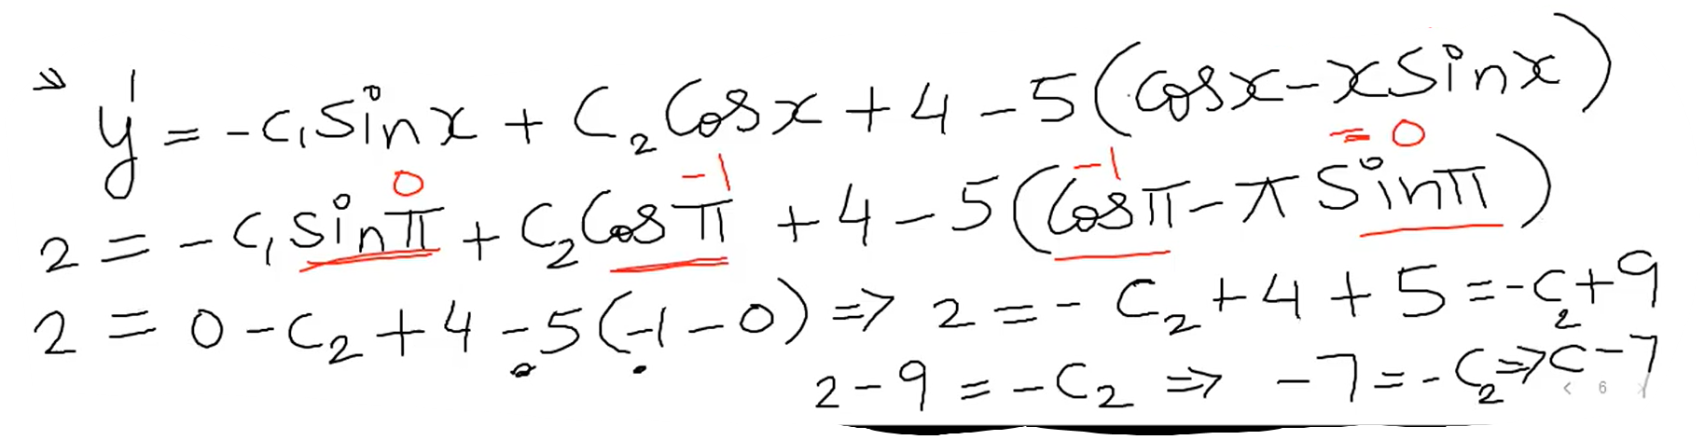

13/ Plug c1, c2 into the function in step 11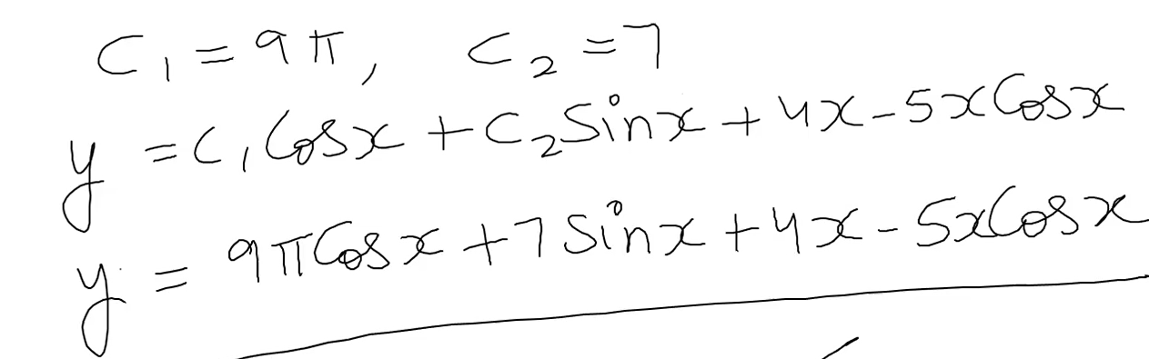

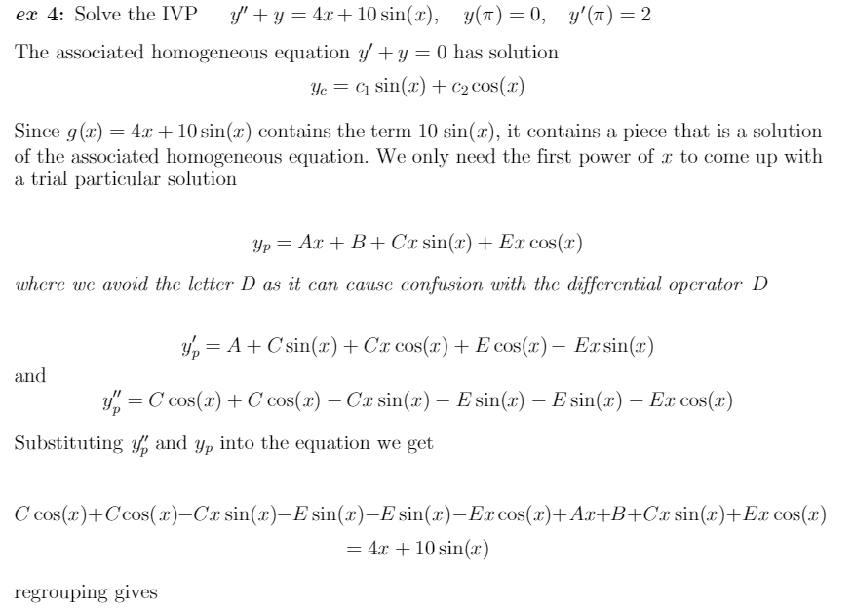

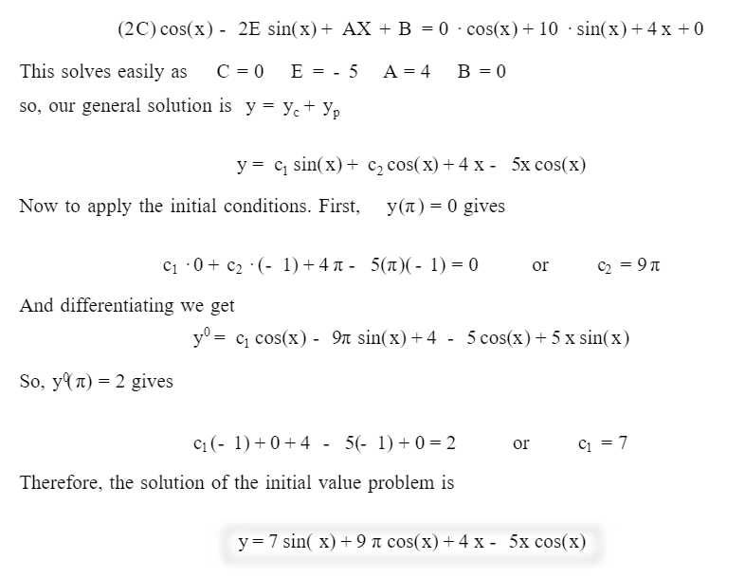

Q5.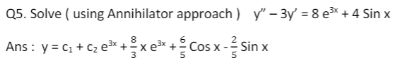



1/ Compare to the gender form 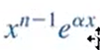 to find n and **α**

2/ 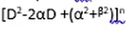Using when have sin or cos function

3/ Find yc. Also need to check cases for roots

4/ Find gender solution

5/ set D = d/dx

Multiply both sides with equation from step 2 and set it = 0

6/ Transform to m equation and find roots

7/ Check cases for each root -> Find the correct formula -> gender solution

8/ We know y = yp + yc

Find yp. Using yc from step 3 -> Plug it in y function from step 7. Check if it has yc or not

9/ Compare the coefficient of given function (pt de bai) with yp

Have yp -> Plug in y’’ + y = the given function (ptrinh đề bài)

Find y’’p to solve the new function

10/ Get the value of A, B, C - > Plug into yp -> Plug yp, yc into y = yc +yp

1/ Compare to the gender form  to find n and **α**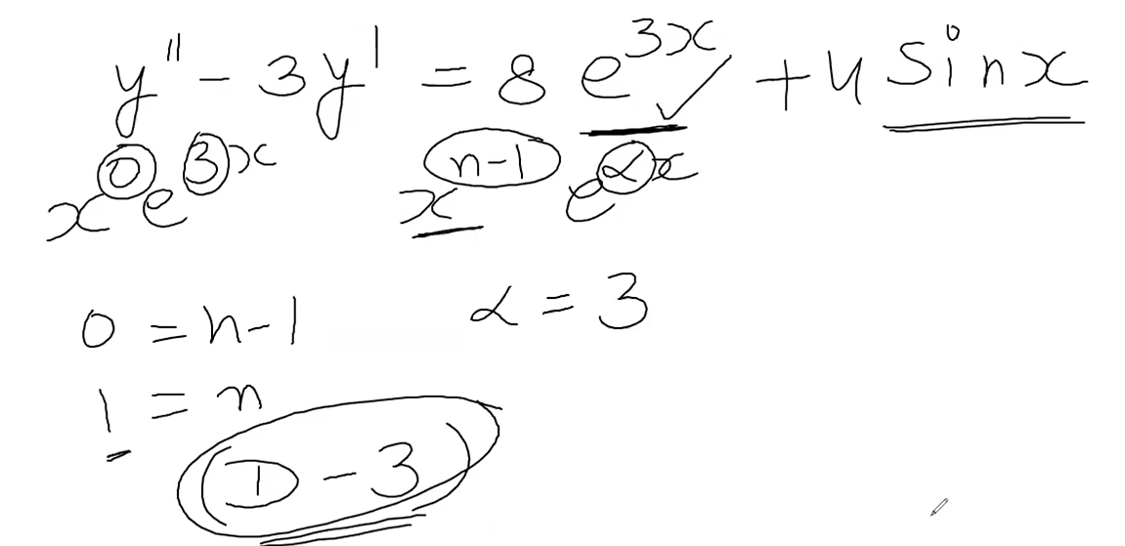

2/ Using when have sin or cos function

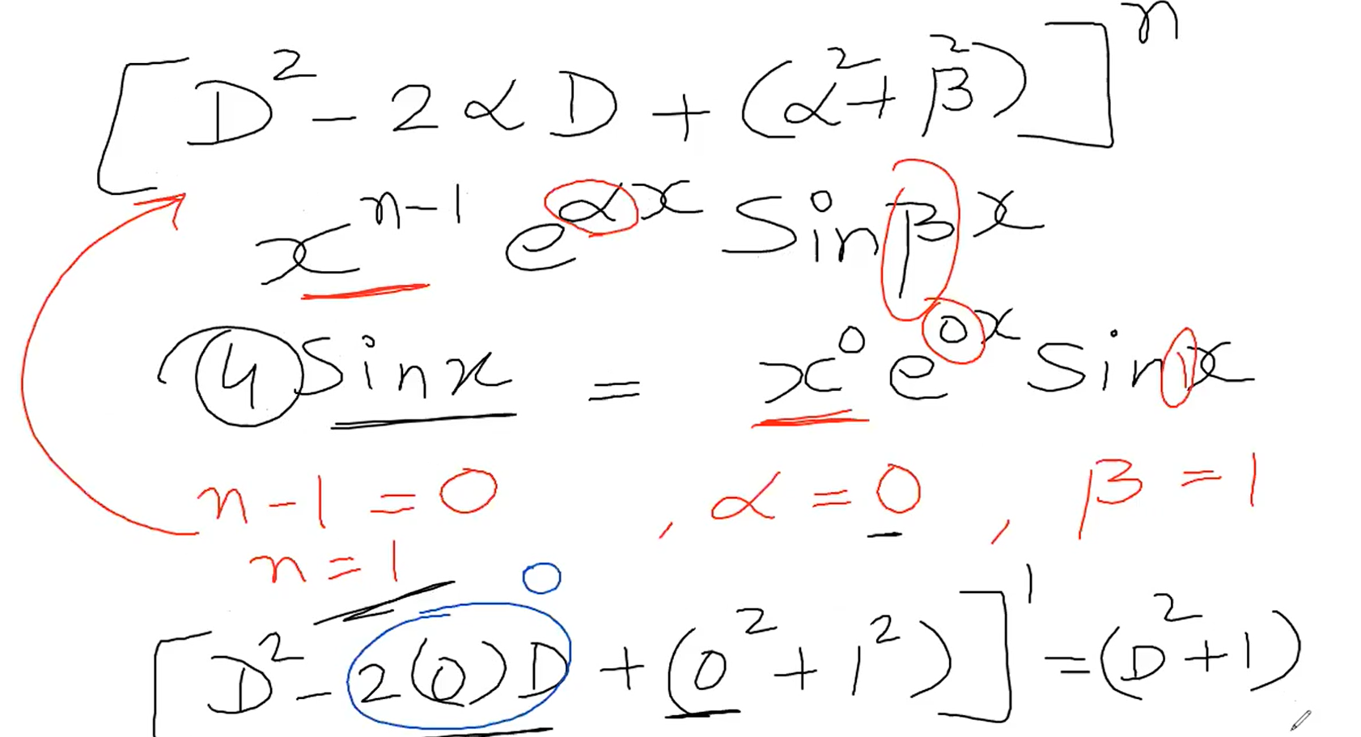

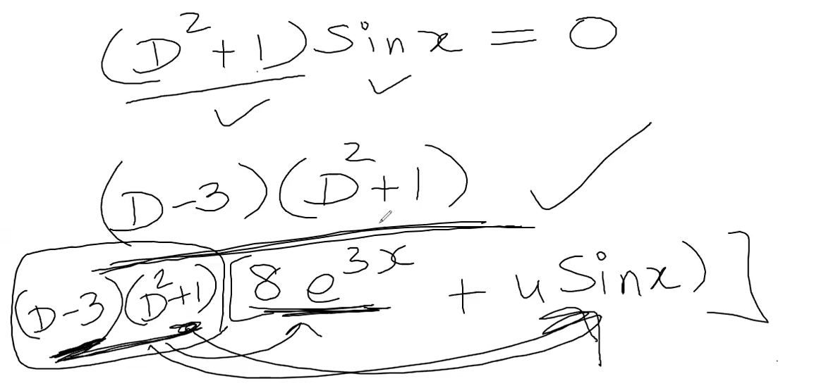

3/ Find yc. Also need to check cases for roots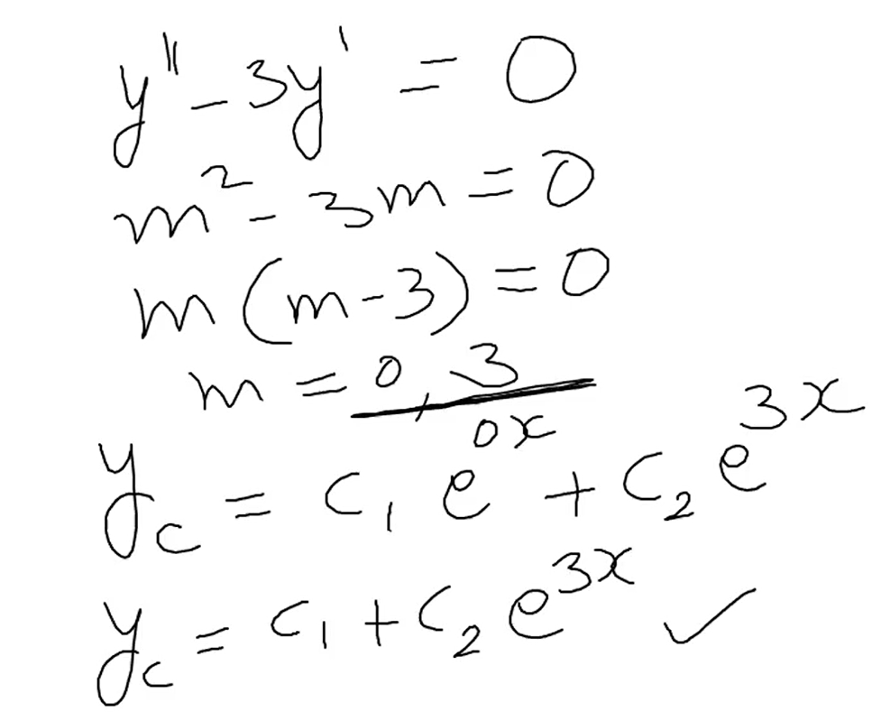

4/ Find gender solution

5/ set D = d/dx

Multiply both sides with equation from step 2 and set it = 0

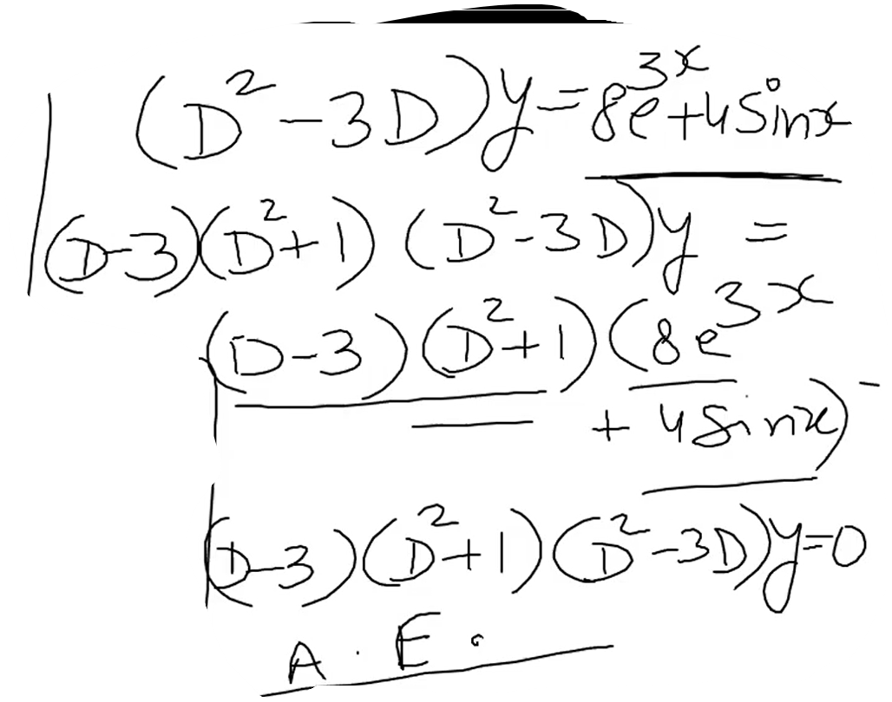

6/ Transform to m equation and find roots

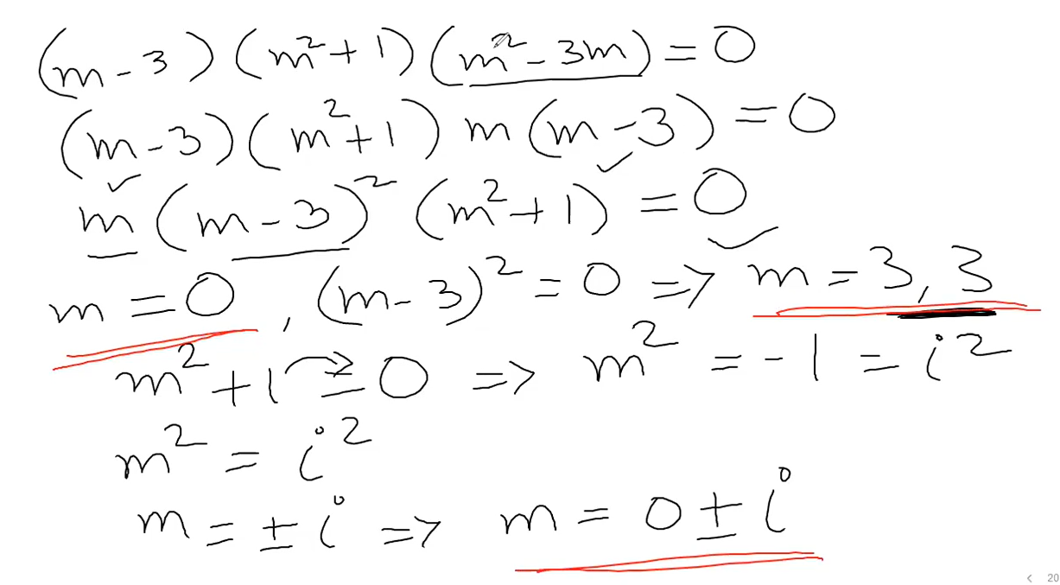

7/ Check cases for each root -> Find the correct formula -> gender solution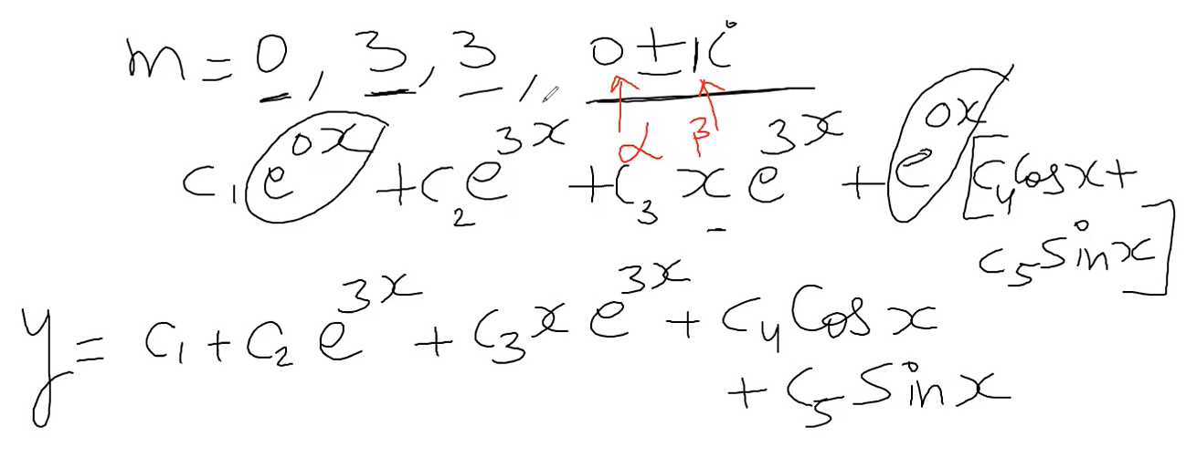

8/ We know y = yp + yc

Find yp. Using yc from step 3 -> Plug it in y function from step 7. Check if it has yc or not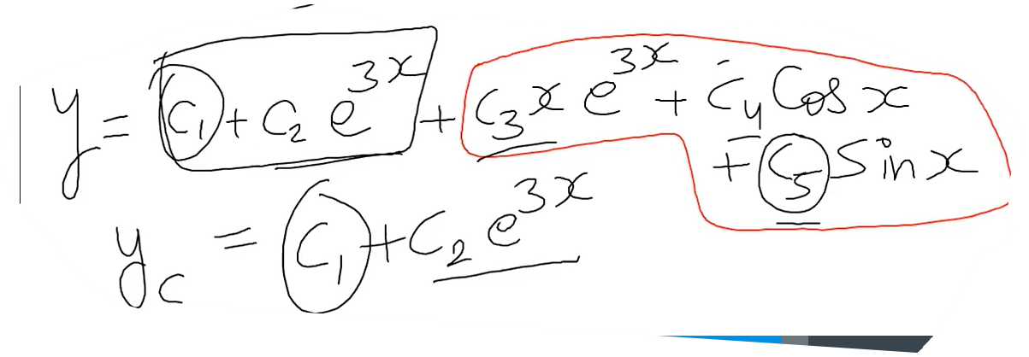

9/ Compare the coefficient of given function (pt de bai) with yp

Have yp -> Plug in y’’ + y = the given function (ptrinh đề bài)

Find y’’p to solve the new function 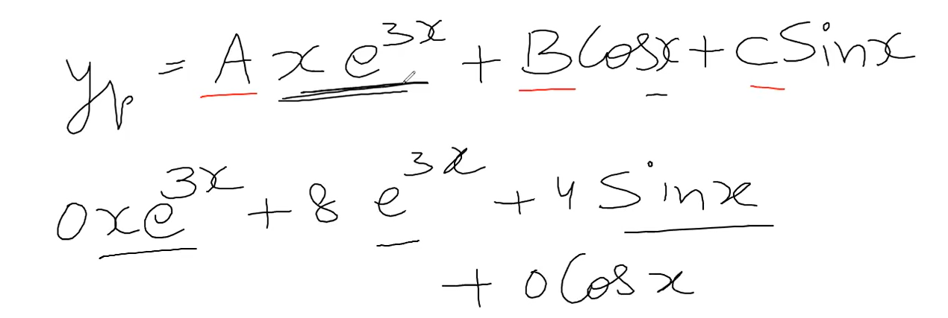

10/ Get the value of A, B, C - > Plug into yp -> Plug yp, yc into y = yc +yp